Installing “C” Clips

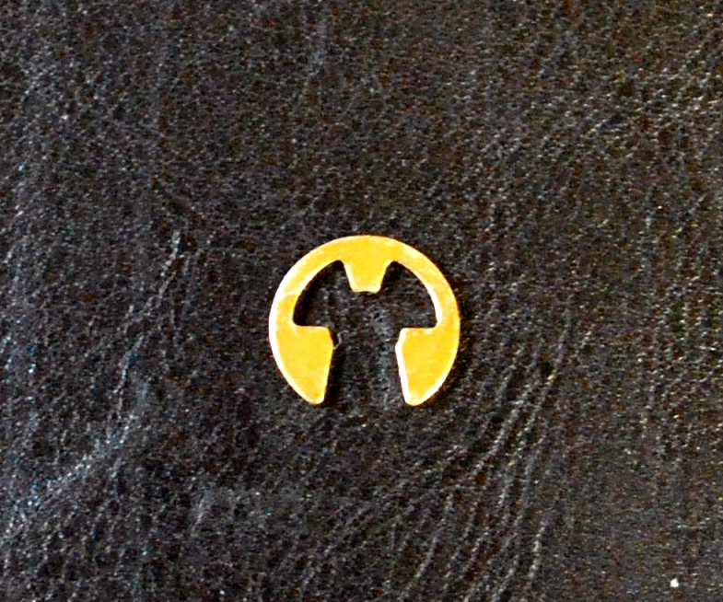
If you get them on correctly they will not come off. However, if they are not properly seated on all three prongs they will come off every time. To the left is a picture of a typical “C” clip. Note the three prongs or protrusions in the inside of the clip. It is imperative that all three of these be firmly seated into the groove in the axle. It is also important that the axle groove not have any accumulated grunge packed into it. Since these photos were taken we have improved the security of the retention by making the groove in the axle twice as wide so two clips can be installed in each groove.

Below are pictures of a “C” clip installed correctly and one partially installed. You can see that it is slightly tilted toward the end of the axle. This is due to the center prong or protrusion not seating itself squarely into the groove in the axle, but rather sitting on the axle shaft above the groove. The other picture shows the “C” clip sitting square to the axle with all three protrusions seated in the axle groove.

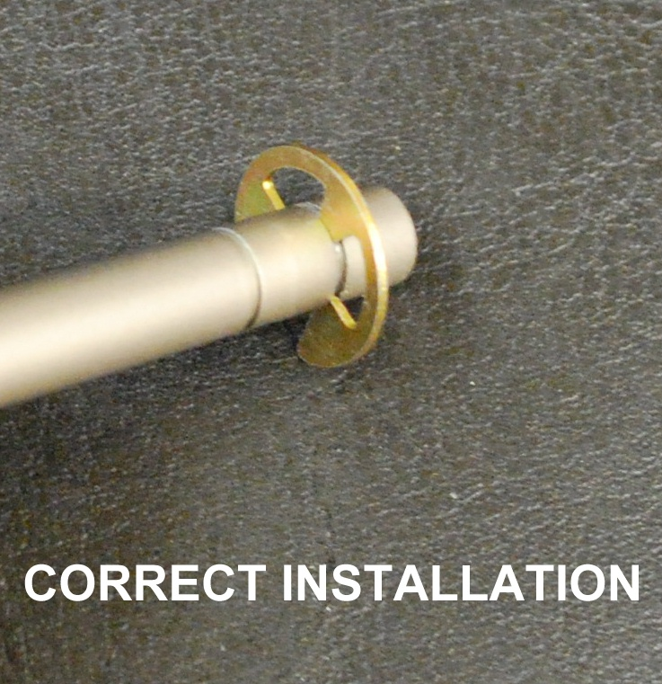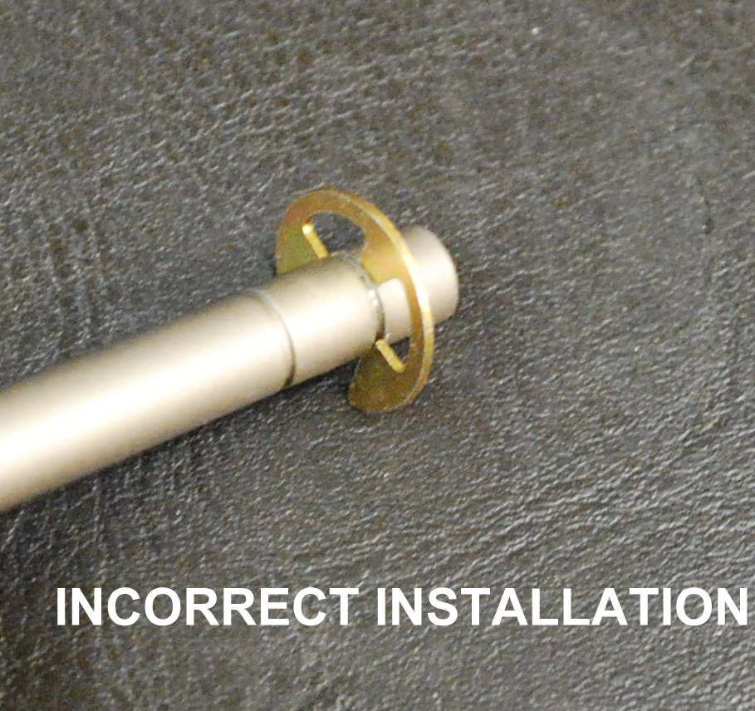

The simplest way to be sure your clips are installed correctly is to be sure the outside diameter of the “C” clip is perfectly centered inside the wheel hub bushing. On the next page are pictures labeled correct and incorrect that clearly show what you should, and should not, see.

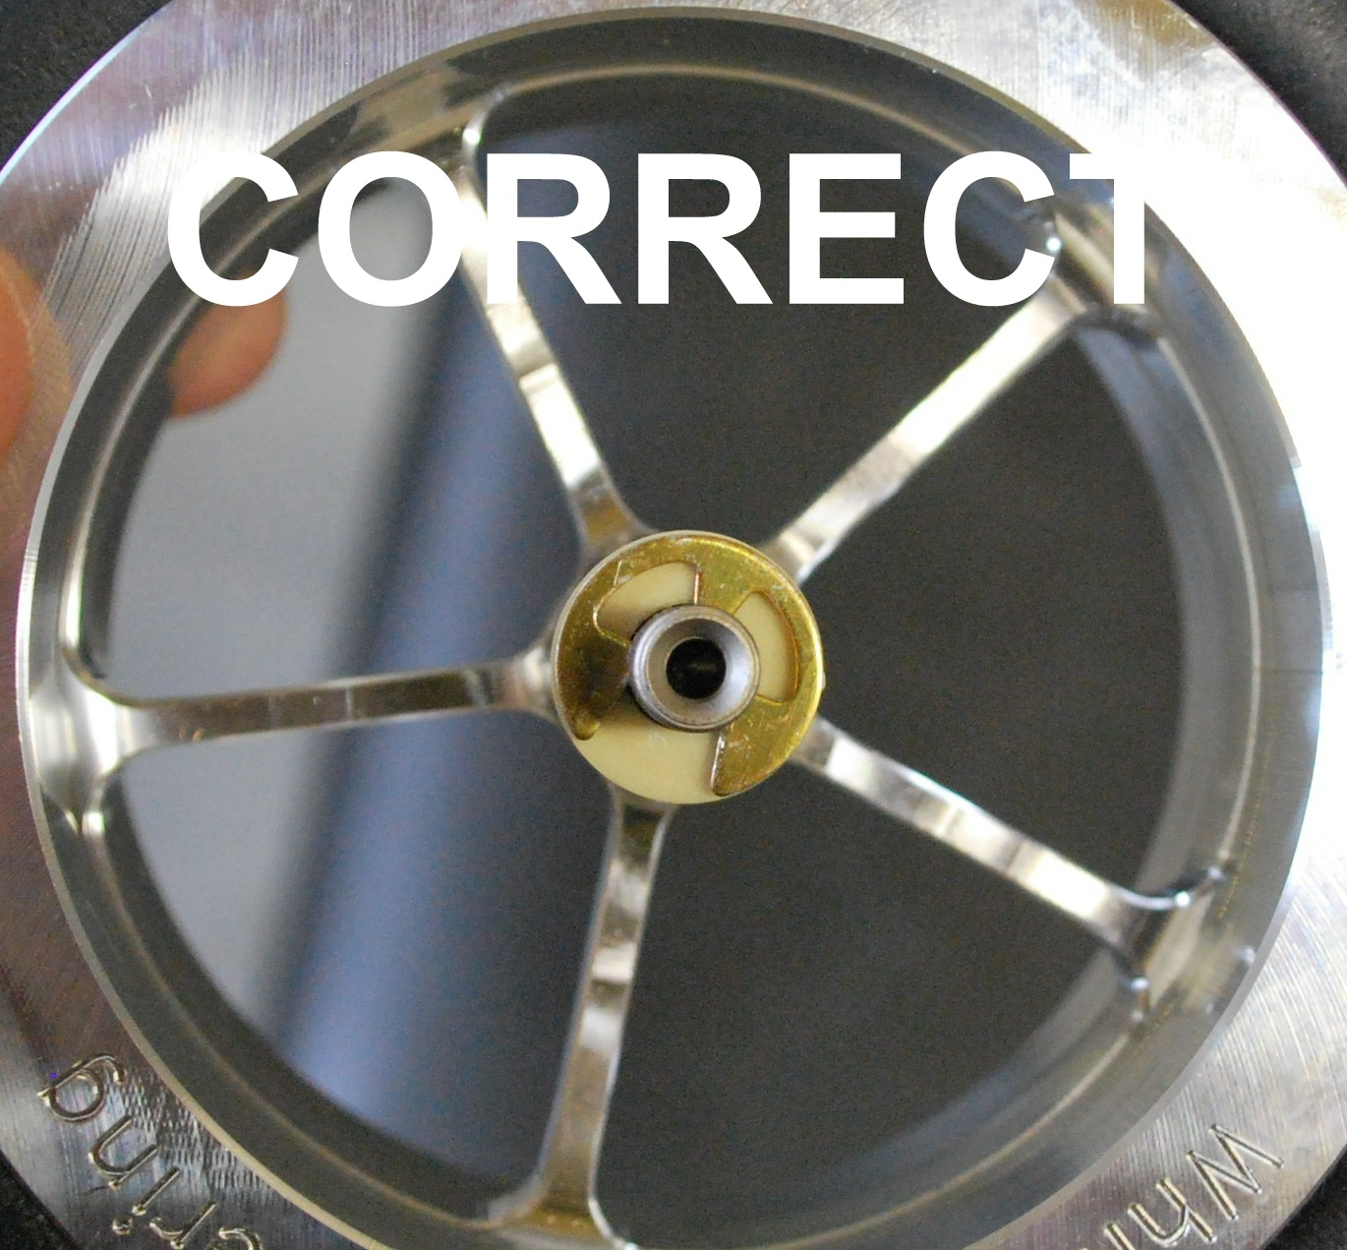

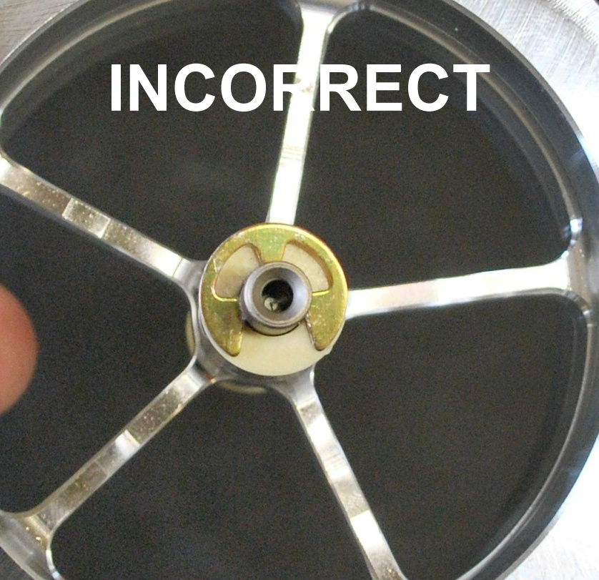

If you are having trouble installing the “C” clip correctly it may be bent. If it is bent the least little bit it will not seat itself into the groove properly and will come off. If you bend one we will gladly send you replacements. They are also available at most high end hardware stores.

Vern Smith
White Rose Engineering

